Overcoming space and time: detecting the effects of dynamic management on plant composition at the Tallgrass Prairie Preserve, OK.

McGlinn, Daniel^{1*}, Earls, Peter¹ and Palmer, Michael¹

Daniel McGlinn
¹ Department of Botany, Life Sciences East 117, Oklahoma State University, Stillwater, Oklahoma, 74078 USA; Email: daniel.mcglinn@okstate.edu
* correspondence author

Peter Earls
Email: earlsp@okstate.edu

Michael Palmer
Email: mike.palmer@okstate.edu

Running head: space, time, and disturbance
Abstract
Question: Is the plant species richness and composition of a tallgrass prairie undergoing change through time and space, and how much of this change can be attributed to management using fire and grazing?
Location: Tallgrass Prairie Preserve in Osage Co., Oklahoma, USA.
Methods: A tallgrass prairie was managed with randomized burning and bison grazing as well as with more traditional management of spring annual burning and cattle grazing since 1993. We annually sampled 100 m² square quadrats located in the grasslands of the preserve for all vascular plant species from 1998 to 2008. Multiple regression with ordinary least squares, generalized least squares, and mixed-effects were used for explanatory modeling and variation partitioning of species richness. Indirect and direct gradient analysis was used to understand the variation in plant composition at this preserve. We utilized partial canonical correspondence analysis (pCCA) and variation partitioning to quantify the partial and shared variation that space, time, and disturbance variables had on species composition.
Results: There was significant change though time in species composition; however, this change was non-directional. Partial disturbance effects only explained 1.9 % of the total inertia which was less than the percent explained by site identity (48.9 %) and year of sampling (4.4 %). The large degree of variation that site identity explained was related to the pH gradient. Plant functional groups differed predictably in their responses to various aspects of management.
Conclusions: Variation in space alone explained a large degree of the variation in plant composition. Therefore, it is important for restoration projects to be designed and interpreted with respect to the relevant spatial environmental gradients.
Keywords: Tallgrass prairie, Canonical correspondence analysis, variation partitioning, restoration ecology, diversity, Osage County, Oklahoma.
Nomenclature: USDA Plants database (2005)
Introduction

Natural variability concepts of land management, which promote spatial and temporal variability, are increasingly utilized in restoration ecology (Palmer et al. 1997). Underling these concepts are two premises: 1) that historical conditions and processes can provide guidance for management, and 2) that spatial and temporal variability generated by disturbance are vital components of nearly all ecosystems (Landres et al. 1999). Managing for historical conditions is thought to benefit species that have evolved in that system and to minimize human alternations (Swanson et al. 1994), and spatial and temporal variability is thought to maintain biological diversity (MacArther 1965, Petraitis et al. 1989). Although these concepts are grounded in ecological theory, Palmer et al. (1997) notes, the importance of managing for natural variability are rarely examined experimentally.

The application of natural variability concepts have strong relevance to the North American tallgrass prairie ecosystem. In this ecosystem fire and grazing were important components of disturbance regime in pre-Columbian North America (Anderson 1990) and still are today (Daubenmire 1968, Abrams et al. 1986, Collins 1992). Although historically the region was grazed by Bos bison L. (bison) and was burned in a variety of seasons, presently much of the remaining tallgrass prairie ecosystem is managed for cattle with annual spring burns (Fuhlendorf and Engle 2001) . The purpose of annual spring burning in is to maximize yields of palatable C4-grasses (Towne and Owensby 1984). Howe (1994) also noted that many restoration efforts on prairie remnants promote production of C4-grasses with spring season burning and a lack of grazing. These management practices may be a threat to the ecosystem’s biodiversity by only benefiting one competitively superior plant-functional group and by homogenizing an entire region’s disturbance regime (Howe 1994, Fuhlendorf and Engle 2001, Nekola and White 2002).

In an effort to restore natural variability to grazing systems, Fuhlendorf and Engle (2001, 2004) suggested that the interaction between fire and grazing could be used in a way to create a shifting mosaic in which only a portion of a given pasture is burned annually. They argued that this mosaic of burned and unburned patches more closely approximates the historical variability that would have existed on the landscape and will result in higher biodiversity then traditional homogenous management practices (annual spring burning). This hypothesis is guiding the management of the Tallgrass Prairie Preserve (TGPP), the largest preserved tallgrass prairie in the world.

The scale of this particular preserve coupled with the spatial and temporal variability of the large-scale treatments, in which entire watersheds are burned, provides both important opportunities and challenges for experimentally evaluating the importance of the natural variability hypothesis. One of the opportunities that this particular preserve offers is the ability to investigate the relative importance of management in a tallgrass prairie ecosystem that is presumably in somewhat of a more pre-European (‘natural’) state given the intact native vegetation, the presence of free ranging bison, and the non-fixed burning regime is implement on the preserve. This opportunity is valuable because the majority of our knowledge on tallgrass prairie ecology either originates from relatively small scale treatment plots or strictly controlled watershed treatments (i.e. Konza prairie LTER). Controlled studies are extremely valuable in elucidating ecological mechanisms that underlay prairie ecology, but they may be less useful in providing the ability to examine the influence of management within a broader ecological context (Halle 2007, Weiher 2007). A key challenge of making statistical inferences from non-controlled systems is developing a sampling design with adequate power that can capture the variability of the ecological community and the signature of management treatments. Additionally, the statistical analysis must be tolerant of non-constant treatments (i.e. variable management through time) and temporal autocorrelation given that inferences in these systems are often based upon resampling of permanent plots. However, these data-analytical challenges are not unique to this study system. A key aspect of management plans on many nature preserves is flexibility; therefore, it is often not logistically feasible or pragmatic to establish controlled landscape scale experiments ref. Therefore, these challenges can also be viewed as an opportunity to demonstrate sampling and analytical methods that are useful for drawing inference from the non-controlled experimental setting that the Tallgrass Prairie Preserve offers (Legg and Nagy 2006, Murray and Conner 2009).

With these opportunities and challenges in mind, the purpose of this study was to investigate the variation in plant species richness and composition in space and time at the TGPP, and to detect the relative importance of management using prescribed burning and grazing by bison and/or cattle. As noted above a randomized block design of burning and grazing treatments is not easily implemented on the preserve, and therefore our study is observational in nature. Differences due to management within a sample are likely to be strongly confounded by year-to-year variation in climate (Anderson 1982), variation in soil (Critchley et al. 2002), and variation in topography (Briggs and Knapp 1995). However, these confounding variables can be used as covariables in multiple regression and partial canonical correspondence analysis (pCCA; Borcard et al. 1992) so that the amount of variation only explained by management can be quantified relative to other explanatory variables.

Using a mixture of explanatory modeling and ordination techniques we addressed three related questions. Is there directional change in species richness and species composition through time? What are the most important environmental variables for explaining plant richness and composition? If space and time are factored out does disturbance significantly correlate with richness or composition and in what way?
Methods
Study Site:
The TGPP is a 15,700 ha nature preserve located between 36.73° and 36.90° N latitude, and 96.32° and 96.49° W longitude, in Osage County, Oklahoma and owned by The Nature Conservancy (TNC). The preserve is situated at the southern extent of the Flint Hills region. The elevation of the preserve ranges from 253 to 366 m, and the underlying bedrock of the region is characterized by soils deriving from Permian sediment (Oviatt 1998). Due to long-term erosion, the surface layers of soil are thin and young; limestone and sandstone are frequently exposed at the surface, sometimes within close proximity of each other. Because of this rockiness the Flint Hills region, including the Tallgrass Prairie Preserve, has remained unplowed and has been instead utilized as rangeland for cattle. Previous to the acquisition of the preserve by TNC in 1989, the majority of the site was managed for cow-calf and yearling cattle production with a 4- to 5-year rotation of prescribed burning and aerial application of broadleaf herbicides (1950-1989) (Hamilton 2007).

Approximately 90 % of the TGPP consists of grasslands. The majority of the grasslands are composed of tallgrass prairie habitats dominated by Andropogon gerardii, Sorghastrum nutans, Sporobolus compositus, Panicum virgatum, and Schizachyrium scoparium. Shortgrass prairie habitat occurs to a lesser extent on more xeric sites and is dominated by Bouteloua spp. Despite the application of herbicide earlier in the century the flora of the preserve appears relatively intact with a total of nearly 800 species of vascular plants (Palmer 2007).

Management:
The management at the TGPP was variable in space and time. In 1993, 300 Bison bison (bison) were introduced year-round onto a 1,960 ha portion of the preserve (Hamilton 1996, 2007). As the bison herd increased in size, the area allotted to the herd was increased eight times to an area of 8,517 ha by 2007 (Fig. 1, 54% of preserve area). Within the bison unit animals were allowed to range freely and their movement was not obstructed by internal fences. Watersheds within the bison unit were considered randomly for burning only if they met the minimum fuel criteria of 900 kilograms per hectare of fine fuels. Within a given year, the season of burn of the bison unit was split as follows: 40 % dormant spring (March - April), 20 % late growing season (August - September), and 40 % dormant winter (October - December); however, this was only a general prescription and prone to variation as well (Hamilton 1996, 2007). The remainder of the preserve was seasonally grazed by cattle and typically burned more frequently in the dormant spring season, but some of the cattle pastures were utilized for smaller scale (2,350 ha) patch-burn experiments in which only one-sixth of a given management unit was burned annually (Hamilton 2007). Stocking within the cattle pastures included both intensive-early stocking and season-long stocking.

Data collection:
Because of the temporally variable and spatially aggregated nature of the management, we opted to annually re-sample a semi-random, spatially stratified set of twenty square 100 m² plots located at the intersections of the 1-km UTM grid. The only criteria that we imposed on the selection of our plots was that they contain less than 20 % of woody cover, standing water, or exposed rock. An un-biased spatial stratification of samples is an ideal sampling method for ensuring that samples are an unbiased representation of the broader variation in grassland communities across the preserve. Also an assumption of spatial independence is justifiable, with our design, given that the minimum distance between any two samples (1000 m) is almost two orders of magnitude larger than the maximum distance captured within a given sample (≈14.14 m). Long-term resampling of our plots allowed us to: 1) observe vegetation in multiple management states (e.g., one year post burn, bison vs. cattle grazed), 2) consider the role of management after considering year to year variation. We resampled our plots every June from 1998 to 2008 and recorded the percent cover of all vascular plant species. Each year we combined four 10 cm soil core samples for each vegetation sample and sent these to Brookside Labs (New Knoxville, Ohio) to be analyzed for soil cations, pH, and other variables. We recorded topographic data on slope and aspect in the field. For each sample we derived management variables including years since last burn, years of bison grazing, and number of burns in the past five years from a GIS database that we developed based on TNC’s recorded burn and grazing history. It is important to note that all of these disturbance variables are dynamic in time, meaning that that there were not fixed treatments.

Data analysis:
We were interested in quantifying the relative roles of within and between sample variance both with respect to species richness and species composition. For dissecting relationships between species richness and our various explanatory variables we utilized ordinary least squares (OLS), generalized least squares (GLS), and linear mixed-effect (LME) multiple regression models. In order to account for within-sample temporal autocorrelation we incorporated a first-order autoregressive term in our GLS and LME models. Our LME models allowed us one additional level of complexity in that we could model within sample effects as random effects and the between sample effects as fixed effects. This was beneficial because… In all the analyses we treated species richness as a continuous variable with normally distributed error. We recognized that in some modeling contexts it is more appropriate to consider richness as a Poisson distributed variable (rather than a normal one) (Candy 1997, Palmer and Hussain 1997). However, because the normal distribution provides a good approximation of a Poisson random variable when the mean is larger than approximately 20; we feel that our usage of normal errors (instead of Poisson) is justified given that richness was never below 48 in our samples. We also recognize that some authors consider richness to only be one facet of grassland biodiversity and that other diversity indices can yield more insight into the ecology of the system (Chalcraft et al. 2009). This may be potentially true but in this study, richness was so strongly correlated with the Shannon diversity index, Simpson’s index and Evenness that these indices will yield little additional insight (See appendix #). In order to determine the importance of a given explanatory variable we implemented hierarchical partitioning to estimate independent and shared effects of each variable with R package hier.part (Chevan and Sutherland 1991, Walsh and Mac Nally 2008, Murray and Conner 2009). To examine the relative importance of site, years, and management effects we utilized a variation partitioning procedure (Legendre and Legendre 1998, Peres-Neto et al. 2006).

We utilized both indirect and direct ordination methods to examine changes in species composition. Prior to all ordinations, we square-root transformed all species cover data, down-weighted rare species, and log-transformed the soil variables (Palmer 1990). Aspect was converted in a measurement of northness [northness = cos(aspect)] (Roberts 1986). We did not consider a corresponding index of eastness because of difficulties in ecological interpretation and exploratory results indicated it was unimportant. Detrended Correspondence Analysis (DCA; Hill and Gauch 1980) was used to visually inspect directional change in the plant composition through time for all three subsets of the data and to get an estimate of the amount of variation the species displayed across a hypothetical environmental gradient. Non-metric multidimensional scaling (NMS), another indirect ordination technique that in contrast to DCA does not assume the existence of a hypothetical environmental gradient, was used to confirm the general conclusions of the DCA. Partial canonical correspondence analysis (pCCA) was used to perform variation partitioning on space, time, and management variables (Borcard et al. 1992, Okland 1999). We used site identity as a controlling variable for spatial variation and year of sample as a controlling variable for change through time. All management variables were included in this analysis. Site identity and year of sample were specified as dummy variables. Monte Carlo randomization tests were used with 999 iterations to determine significance of all canonical axes for all partial CCA analyses under the reduced model (Legendre and Legendre 1998). These randomizations were constrained by strata which consisted either of site identity or year depending on the explanatory variable of interest. We preformed multivariate analyses with CANOCO version 4.5 and the R package vegan (ter Braak and Šmilauer 2002, Oksanen et al. 2008, R Developmental Core Team 2008).

Results
Variance in species richness
The average species richness over the 11 year study at 100 m² was 76.24 (± 0.86). The within site variance (σ = 9.13) in richness was approximately equal the between plot variance (σ = 8.93). Variation partitioning based on the unbiased estimate of variance explained by OLS, R²-adjusted (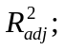Fig. 2), indicated that between site differences explained the majority of the variance in richness (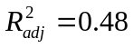), followed by year-to-year differences (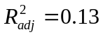). However, after the within-site temporal autocorrelation was considered (using the first-order auto-regressive term); plot identity and year identity seemed to explained equal fractions of unshared variation according to Nagelkerke’s (1991) generalized definition of the coefficient of determination (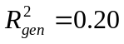) which is based upon a ratio of log-likelihoods.
In comparison, management accounted for a much smaller percentage of explained variance in richness (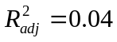), but still contributed a significant amount of explained variance as judged by marginal (type III) parametric and randomization-based tests with an alpha level 0.05 (Table 1). There was also a reasonably large shared site-by-management shared component of variance (7 %).
With respect to the independent variance (i.e. not considering the shared variance) explained by the three classes of variables. The variation partitioning indicated that independent site effects controlled the majority of variance in richness (), followed by independent year-to-year variation and hierarchical partitioning both indicated relatively similar
Directional change in composition
The overall variation along the first and second DCA axes was relatively similar with a gradient length of 2.235 for the first axis and 1.818 for the second axis. Together the first and second axis described 18.1 % of the total variation in species composition. The DCA scatter plot of samples indicated that there is not a clear pattern of directional change through time (Figure 2), but a pCCA with year of sample as the explanatory variable and the site identities as the covariables indicated that within quadrats there was some linear directionality in species composition (λ=0.015, p < 0.001).
Space, time, and disturbance
Site identity and year both explained a significant amount of the variation in species composition (p < 0.001) (Table 2). The disturbance variables were significantly correlated with variation in plant composition in time (p = 0.030) and space (p = 0.013), but only marginally so. The importance of the site identity variable may be explained largely by soil calcium and iron which both were both highly significant after factoring out year and disturbance (Table 2). Years since last burn appeared to be the single most important disturbance variable.

Although the randomization tests indicated that site identity, year, and disturbance were all significantly related to species composition, the results of a variation partitioning of these variables indicate that site identity, or variation in space, is the most important variable by far. These results are presented graphically as Venn diagrams for each pooled set of the data (See Figure 4). For the plots sampled in continuously dynamic or continuously traditional management pastures, partial disturbance effects only explained 2.7 % of the total inertia. Parital site identity explained the most variation in species composition at 43.7 %. Similar results were found in the other subsets of the data as well (Figure 1). As more samples were included in the analysis the total inertia increased. The disturbance variables explained the most variation in the analysis preformed on the dynamic management only sites (set A.) at 5.0 %.

A separate pCCA conducted on soil variables and topography given disturbance and year indicated that log Ca, log Fe, pH, slope, and aspect variables explained 30.2 % of the total inertia, another analysis using just log Ca, log Fe, and pH explained 18.9 % of the variability. This indicates that site to site variation is largely explained by soil variables representing a pH gradient from limestone (basic high calcium) to sandstone (acidic high iron) soils, however; we recognize that other important topographical data was not included in our data that could increase the apparent importance of topography.

A pCCA triplot of disturbance effects on species composition with site identity and year as covariates and percent of total cover of plant functional groups as passive variables (Figure 5) indicates how disturbance correlates with plant functional groups once space and time are controlled. C4 grasses increased in spring burned patches that are burned often, while forbs, and C3 grasses both increased in winter burned patches that are burned less frequently. Legumes and forbs were not strongly correlated with the first or second pCCA axis. The contour lines in figure 5 are lowess lines used to indicate the average species richness of samples occurring in localized ordination space. Richness is highest in the center of the diagram and generally decreased regularly towards the edges. Triplots were constructed for the other two sets of data and qualitatively similar results were found.

Discussion

Our results indicated that the disturbance regime was significantly correlated with plant composition; however, that its effect was relatively minor in comparison to the spatial and temporal heterogeneity of plant composition. Time since last burn was the single most important disturbance variable. The correlation of the plant functional groups with disturbance conformed largely to our expectations. It is well documented that spring frequent burning increases C4 grasses and decreases C3 grasses and forbs (Towne and Owensby 1984, Towne and Kemp 2003). One interesting pattern to note is that sites with the highest species richness seemed to be clustered in the center of the pCCA triplot (figure 5) as indicated by the lowess contour lines. This could be interpreted to indicate that sites with more temporal variation in their burning regieme have more species once once spatial and temporal variation in species richness is controlled for.

Palmer et al. (2003) found that species richness of natives and exotics was strongly negatively related to pH when they analyzed data from plots located across the entire preserve. Our analyses also found log transformed calcium and iron to be important explanatory variables related to plant composition. These variables together represent a continuous environmental pH gradient from limestone to sandstone soils. The majority of the research on the importance of soil composition related to grassland plant composition has focused on the importance of soil nitrogen, phosphorus, and carbon (Burke et al. 1998, Brokaw 2004) and how these soil variables change in response to fire. We did not collect long-term data on carbon and nitrogen variables, but in 2002 a study did measure total C and N at our 20 permanent plots (Brokaw 2004). The results of this study indicated total C explained the most variation in plant composition (20.1 %), however, pH was the second most important variable.

We recommend like some other authors that restoration targets must be viewed within the context of the important environmental gradients that shape community composition (White and Walker 1997, Nekola and White 2002). In tallgrass prairie systems, fire and grazing are extremely important management tools (Collins et al. 1998); however, we warn that small scale experimental studies that simply show the significance of fire and grazing variables on plant functional groups may be overlooking the larger spatial context that ultimately determines whole community composition. Future tallgrass prairie preserve design in the Flint Hills region should strongly consider capturing as much of the limestone to sandstone gradient as possible, in order to achieve a larger degree of complementarily in species composition.

Acknowledgments

We thank Bob Hamilton, Jayne Salisbury, Kindy Chang, Sandy Earls, Sandy Stevens,
Kerry Sublette, James Shaw, Sonia Jaiswal, Chris Sellers, Norman Elliott, Wade French, Suzanne McAlister, Eric Maichak, Ronald Tyrl, Steven Thompson, Reinhard Spiegelhauer, David Nemcock, Linda Gatti-Clark, Karol Ezell, Kevin Belt, Marissa Raglin, Thomas Wohlgemuth, Chris Hise, Dai-Jun Zhang, John Wilson, Jerry Husak, Larry Thiesen, Joshua Brokaw, Jerad Linneman, Ken Hobson, The Oklahoma State University College of Arts and Science, The Oklahoma Nature Conservancy, The Spatial and Environmental Information
Clearinghouse, The Philecology Trust, The Swiss Federal Institute for Forest, Snow and Landscape Research, and the Oklahoma Water Resources Research Institute for assistance at various stages of research at the Tallgrass Prairie Preserve.

References:
Tables
Table 1. The results of Monte Carlo randomization tests using the results of a pCCA and 999 iterations.

Explanatory Variable | Covariables | Type of Randomization | F-ratio | p-value | sig.
site | year & disturbance | cyclic | 9.813 | < 0.001 | ***
year | site & disturbance | random | 2.928 | < 0.001 | ***
disturbance variables | site & year | random | 1.718 | 0.013 | **
 |  | cyclic | 1.718 | 0.030 | *
log Ca | year & disturbance | random | 9.948 | < 0.001 | ***
log Fe | year & disturbance | random | 6.006 | < 0.001 | ***
years since burn | site & year | random | 1.506 | 0.004 | **
 |  | cyclic | 1.506 | 0.019 | *
frequency of burns in past 5-years | site & year | random | 1.453 | 0.025 | *
 |  | cyclic | 1.453 | 0.049 | *
season of burn | site & year | random | 1.543 | 0.027 | *
 |  | cyclic | 1.543 | 0.034 | *
Figures
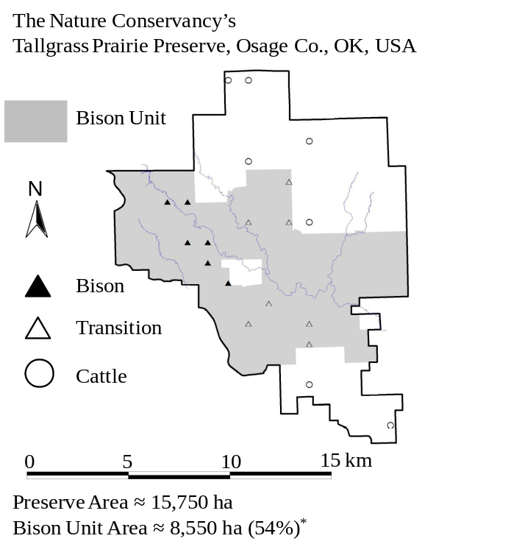
Figure 1. A map of the Tallgrass Prairie Preserve. The shaded area denotes the bison unit which increased in area during the duration of the study. The twenty quadrats sampled each year of this study are displayed on the map. The sites that were bison at the beginning of the study (1998) are displayed with filled triangles (▲), those that transitioned during the study from cattle to bison are denoted by unfilled triangles (Δ), and the other cattle grazed samples are denoted by unfilled circles (○). *Area of bison unit is as of May 1, 2008.

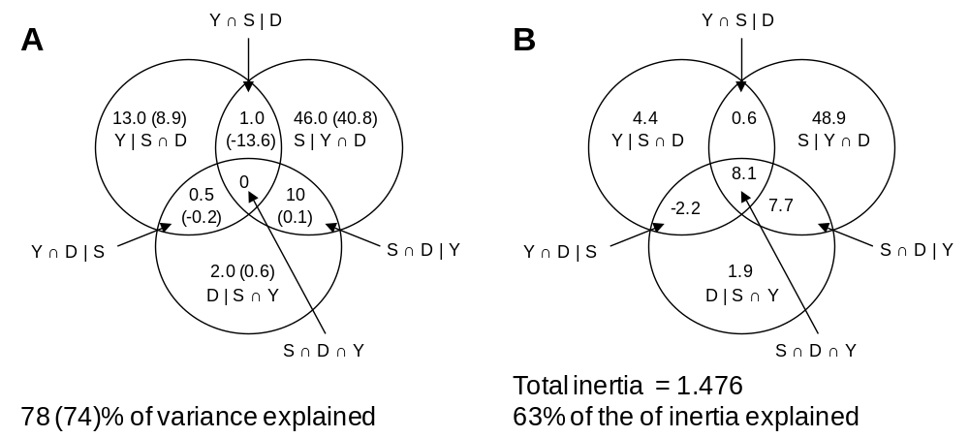
Figure 2. Venn diagrams displaying the result of the variation partitioning on species richness (A) and species composition (B), respectively, into components explained by site (S), year (Y), and disturbance variables (D). The values in A are the coefficients of determination (R²) and the adjusted-R² (values in parentheses) multiplied by 100. In B, the percent of inertia was calculated for each partition by dividing the sum of all canonical eigenvalues by the total inertia and multiplying by 100. Data on richness and species cover was analyzed from the largest spatial grain (100 m²). The inherent autocorrelation in the repeated samples was not corrected for.
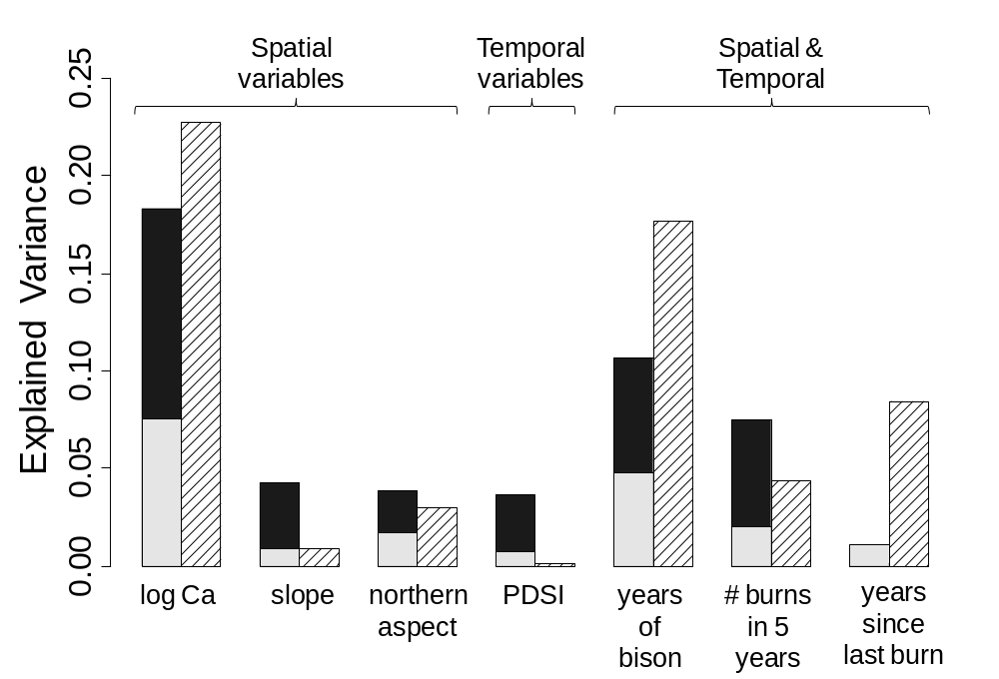
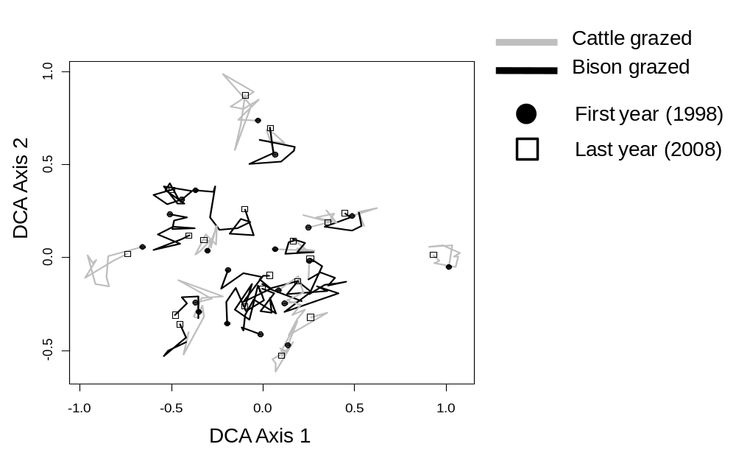
Figure #. DCA scatterplot (the eigenvalues were 0.139 and 0.094 for the first and second axis respecitively) displaying the 20 quadrats from 1998 to 2008. The time series is indicated by a line segment (—) with joints at each year, a dark black line joins years in which the plot experienced bison grazing and a grey line demarcates years in which the plot experienced cattle grazing. The 1998 samples are indicated by circles (●) and the 2008 samples are indicated by squares (□).
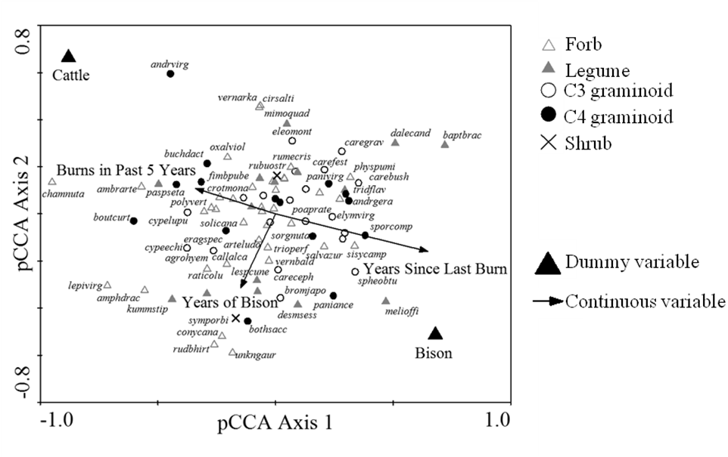
Figure #. pCCA triplot of the disturbance regime given years and sites as covariables. The explanatory variables in the model are indicated by black arrows and large, solid triangles.

Table #. Variance partitioning of richness into the its explained variance components for site (S), year (Y), and disturbance variables (D). The table displays the unadjusted and adjusted OLS coefficients of determination (also displayed in Fig. #), as well as, the generalized coefficients of determination for a GLS model incorporating a single autoregressive term for lags of 1 year.
 | OLS |  | GLS
Variable Class (q) | R² | R²_{adj} | Gen. R^{2*}
S | Y ∩ D (19) | 0.46 | 0.41 | 0.33
Y | S ∩ D (10) | 0.13 | 0.09 | 0.38
D | S ∩ Y (4) | 0.02 | 0.06 | 0.08
S ∩ Y | D | 0.01 | -0.14 | -0.09
S ∩ D | Y | 0.10 | 0.00 | -0.03
Y ∩ D | S | 0.05 | -0.02 | 0.01
S ∩ Y ∩ D | 0.00 | 0.00 | -0.14
Total (33) | 0.78 | 0.74 | 0.65
*Gen. R² = generalized coefficient of determination (Nagelkerke 1991)

